**## Unit 11 Submission File: Network Security Homework**

**### Part 1: Review Questions**

**#### Security Control Types**

The concept of defense in depth can be broken down into three different security control types. Identify the security control type of each set of defense tactics.

1. Walls, bollards, fences, guard dogs, cameras, and lighting are what type of security control?

**Answer:** *Physical Control*

2. Security awareness programs, BYOD policies, and ethical hiring practices are what type of security control?

**Answer:** *Management Control*

3. Encryption, biometric fingerprint readers, firewalls, endpoint security, and intrusion detection systems are what type of security control?

**Answer:** *Data Protection Access Control*

#### Intrusion Detection and Attack indicators

1. What's the difference between an IDS and an IPS?

**Answer:**

***IDS (Intrusion Detection Systems):*** *analyze and monitor network traffic for signs that indicate attacekrs are using a known cyberthreat to infiltrate or steal data from your network. IDS systems compare the current network activity to a known threat database to detect several kinds of behaviors like security policy violations, malware, and port scanners.*

***IPS (Intrusion Prevention Systems):*** *live in the same area of network as a firewall, between the outside world and the internal network. IPS proactively deny network traffic based on a security profile if that packet represents a known security threat.*

2. What's the difference between an Indicator of Attack and an Indicator of Compromise?

**Answer:** *An IOC is evidence on a computer that indicates that the security of the network has been breached. On the other hand, Indicators of Attack (IOAs) focus on detecting the intent of what an attacker is trying to accomplish, regardless of the malware or exploit used in an attack. Just like AV signatures, an IOC-based detection approach cannot detect the increasing threats from malware-free intrusions and zero-day exploits.*

**#### The Cyber Kill Chain**

Name each of the seven stages for the Cyber Kill chain and provide a brief example of each.

1. Stage 1: ***Reconnaissance:*** *the attacker/intruder chooses their target. They then conduct an in-depth research on this target to identify its vulnerabilities that can be exploited.*

2. Stage 2: ***Weaponization:*** *the intruder creates a malware weapon like a virus, worm or such in order to exploit the vulnerabilities of the target. Depending on the target and the purpose of the attacker, this malware can exploit new undetected vulnerabilities or on a combination of different vulnerabilities.*

3. Stage 3: ***Delivery:*** *transmitting the weapon to the target. The intruder/attacker can employ different methods like USB drives, email attachments and websites for this purpose.*

4. Stage 4: ***Exploitation:*** *the malware starts the action. The program code othe the malware is triggered to exploit the target’s vulnerabilities.*

5. Stage 5: ***Installation:*** *Malware installs an access point for the intruder/attacker.*

6. Stage 6: ***Command and Control:*** *Malware gives the intruder/attacker access in the network/system.*

7. Stage 7: ***Actions on Objectives:*** *Once the attacker/intruder gains persistent access, they finally take action to fulfill their purpose, such as encryption for ransom, data exfiltration or even data destruction.*

**#### Snort Rule Analysis**

Use the Snort rule to answer the following questions:

**Snort Rule #1**

```bash

alert tcp $EXTERNAL_NET any -> $HOME_NET 5800:5820 (msg:"ET SCAN Potential VNC Scan 5800-5820"; flags:S,12; threshold: type both, track by_src, count 5, seconds 60; reference:url,doc.emergingthreats.net/2002910; classtype:attempted-recon; sid:2002910; rev:5; metadata:created_at 2010_07_30, updated_at 2010_07_30;)

```

1. Break down the Sort Rule header and explain what is happening.

**Answer: *alert tcp $EXTERNAL_NET any -> $HOME_NET5800:5820.*** *It is scanning ET SCAN Potential VNC Scan 5800-5820” and alerting users of any inbound TCP traffic from ports 5800:5820*

2. What stage of the Cyber Kill Chain does this alert violate?

**Answer:** *Stage 1 Reconnaissance*

3. What kind of attack is indicated?

**Answer:** *Potential VNC Scan*

**Snort Rule #2**

```bash

alert tcp $EXTERNAL_NET $HTTP_PORTS -> $HOME_NET any (msg:"ET POLICY PE EXE or DLL Windows file download HTTP"; flow:established,to_client; flowbits:isnotset,ET.http.binary; flowbits:isnotset,ET.INFO.WindowsUpdate; file_data; content:"MZ"; within:2; byte_jump:4,58,relative,little; content:"PE|00 00|"; distance:-64; within:4; flowbits:set,ET.http.binary; metadata: former_category POLICY; reference:url,doc.emergingthreats.net/bin/view/Main/2018959; classtype:policy-violation; sid:2018959; rev:4; metadata:created_at 2014_08_19, updated_at 2017_02_01;)

```

1. Break down the Sort Rule header and explain what is happening.

**Answer:** *Alerts for inbound TCP traffic on port 80, HTTP*

2. What layer of the Defense in Depth model does this alert violate?

**Answer:** *Policies, awareness & procedures*

3. What kind of attack is indicated?

**Answer:** *Policy PE EXE or DLL file download*

**Snort Rule #3**

- Your turn! Write a Snort rule that alerts when traffic is detected inbound on port 4444 to the local network on any port. Be sure to include the `msg` in the Rule Option.

**Answer:** *alert tcp $EXTERNAL_NET 4444 -> $HOME_NET any (msg: "ET Possible Trojan or CrackDown)*

**### Part 2: "Drop Zone" Lab**

#### Log into the Azure `firewalld` machine

Log in using the following credentials:

- Username: `sysadmin`

- Password: `cybersecurity`

**#### Uninstall `ufw`**

Before getting started, you should verify that you do not have any instances of `ufw` running. This will avoid conflicts with your `firewalld` service. This also ensures that `firewalld` will be your default firewall.

- Run the command that removes any running instance of `ufw`.

```bash

$ ***sudo apt -y remove ufw***

```

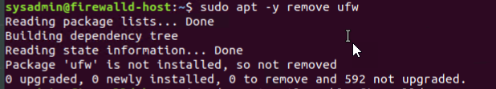

**#### Enable and start `firewalld`**

By default, these service should be running. If not, then run the following commands:

- Run the commands that enable and start `firewalld` upon boots and reboots.

```bash

$ ***sudo systemctl enable firewalld***

$ ***sudo systemctl start firewalld***

```



Note: This will ensure that `firewalld` remains active after each reboot.

**#### Confirm that the service is running.**

- Run the command that checks whether or not the `firewalld` service is up and running.

```bash

$ ***sudo firewall-cmd –state***

```



**#### List all firewall rules currently configured.**

Next, lists all currently configured firewall rules. This will give you a good idea of what's currently configured and save you time in the long run by not doing double work.

- Run the command that lists all currently configured firewall rules:

```bash

$ ***sudo firewall-cmd –list-all***

```

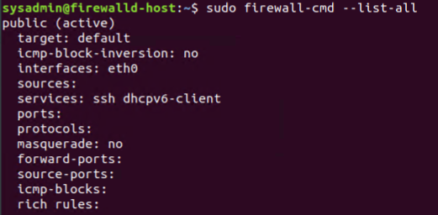

- Take note of what Zones and settings are configured. You many need to remove unneeded services and settings.

**#### List all supported service types that can be enabled.**

- Run the command that lists all currently supported services to see if the service you need is available

```bash

$ ***sudo firewall-cmd –get-services***

```

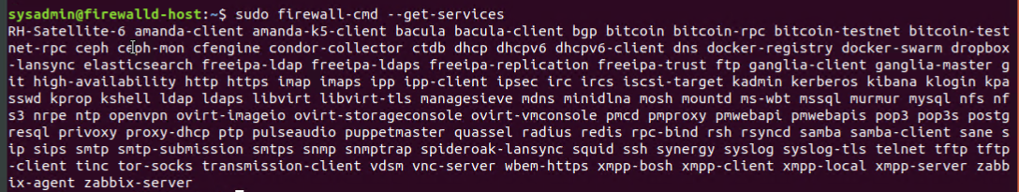

- We can see that the `Home` and `Drop` Zones are created by default.

**#### Zone Views**

- Run the command that lists all currently configured zones.

```bash

$***sudo firewall-cmd –list-all-zones***

```

Example snippet

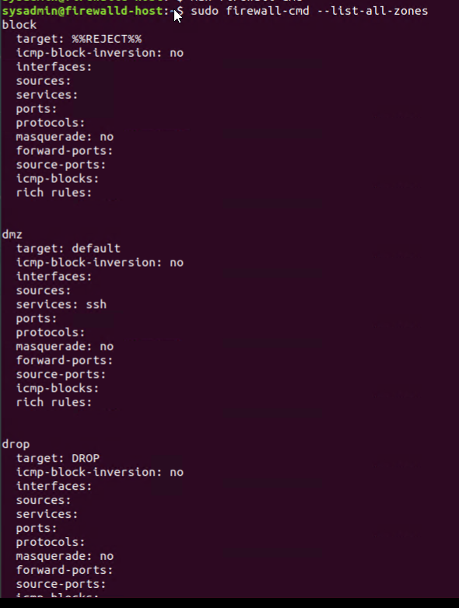

- We can see that the `Public` and `Drop` Zones are created by default. Therefore, we will need to create Zones for `Web`, `Sales`, and `Mail`.

**#### Create Zones for `Web`, `Sales` and `Mail`.**

- Run the commands that creates Web, Sales and Mail zones.

```bash

$ ***sudo firewall-cmd –permanent –new-zone=web***

$ ***sudo firewall-cmd –permanent –new-zone=mail***

$ ***sudo firewall-cmd –permanent –new-zone=sales***

```

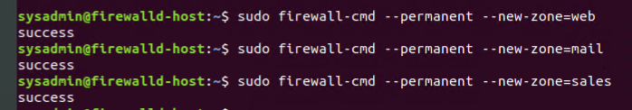

**#### Set the zones to their designated interfaces:**

- Run the commands that sets your `eth` interfaces to your zones.

```bash

***$ sudo firewall-cmd --zone=public --change-interface=eth0***

***$ sudo firewall-cmd --zone=web --change-interface=eth1***

***$ sudo firewall-cmd --zone=sales --change-interface=eth2***

***$ sudo firewall-cmd --zone=mail --change-interface=eth3***

```

**#### Add services to the active zones:**

- Run the commands that add services to the **public** zone, the **web** zone, the **sales** zone, and the **mail** zone.

- Public:

```bash

***$ sudo firewall-cmd --zone=public --add-service=http***

***$ sudo firewall-cmd --zone=public --add-service=https***

***$ sudo firewall-cmd --zone=public --add-service=pop3***

***$ sudo firewall-cmd --zone=public --add-service=smtp***

```

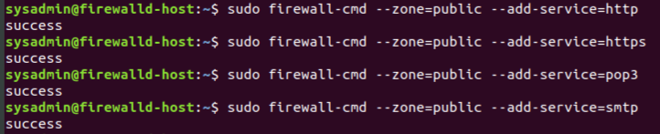

- Web:

```bash

***$ sudo firewall-cmd --zone=web --add-service=http***

```



- Sales

```bash

***$ sudo firewall-cmd --zone=sales --add-service=https***

```



- Mail

```bash

***$ sudo firewall-cmd --zone=mail --add-service=smtp***

***$ sudo firewall-cmd --zone=mail --add-service=pop3***

```

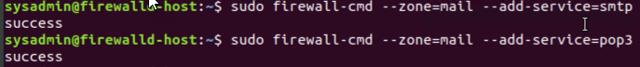

**#### Add your adversaries to the Drop Zone.**

- Run the command that will add all current and any future blacklisted IPs to the Drop Zone.

```bash

***$ sudo firewall-cmd --permanent --zone=drop --add-source=10.208.56.23***

***$ sudo firewall-cmd --permanent --zone=drop --add-source=135.95.103.76***

***$ sudo firewall-cmd --permanent --zone=drop --add-source=76.34.169.118***

```

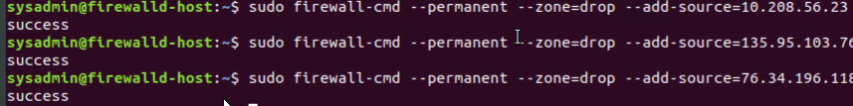

**#### Make rules permanent then reload them:**

It's good practice to ensure that your `firewalld` installation remains nailed up and retains its services across reboots. This ensure that the network remains secured after unplanned outages such as power failures.

- Run the command that reloads the `firewalld` configurations and writes it to memory

```bash

$ ***sudo firewall-cmd --reload***

```

**#### View active Zones**

Now, we'll want to provide truncated listings of all currently **active** zones. This a good time to verify your zone settings.

- Run the command that displays all zone services.

```bash

$ ***sudo firewall-cmd --get-active-zones***

```

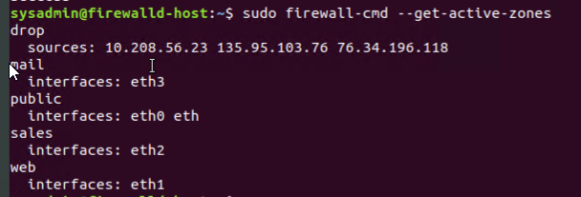

**#### Block an IP address**

- Use a rich-rule that blocks the IP address `138.138.0.3`.

```bash

$ ***sudo firewall-cmd --zone=public --add-rich-rule='rule family="ipv4" source address="138.138.0.3" reject'***

```



**#### Block Ping/ICMP Requests**

Harden your network against `ping` scans by blocking `icmp ehco` replies.

- Run the command that blocks `pings` and `icmp` requests in your `public` zone.

```bash

$***sudo firewall-cmd --zone=public --add-icmp-block=echo-reply --add-icmp-block=echo-request***

```



**#### Rule Check**

Now that you've set up your brand new `firewalld` installation, it's time to verify that all of the settings have taken effect.

- Run the command that lists all of the rule settings. Do one command at a time for each zone.

```bash

***$ <sudo firewall-cmd --zone=public --list-all>***

***$ <sudo firewall-cmd --zone=sales --list-all>***

***$ <sudo firewall-cmd --zone=mail --list-all>***

***$ <sudo firewall-cmd --zone=web --list-all>***

***$ <sudo firewall-cmd --permanent --zone=drop --list-all>***

```

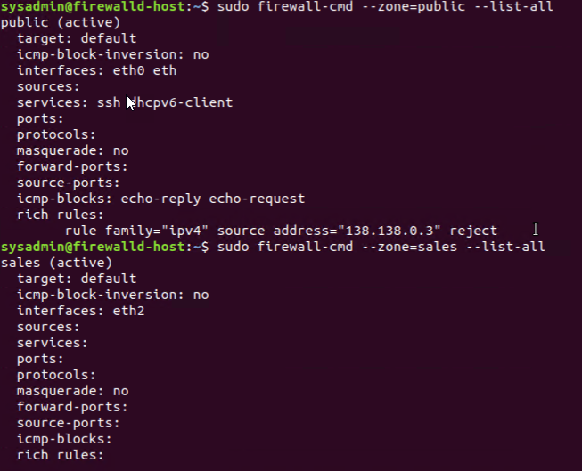

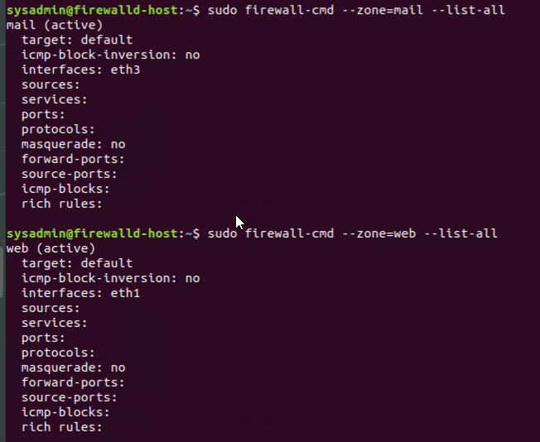

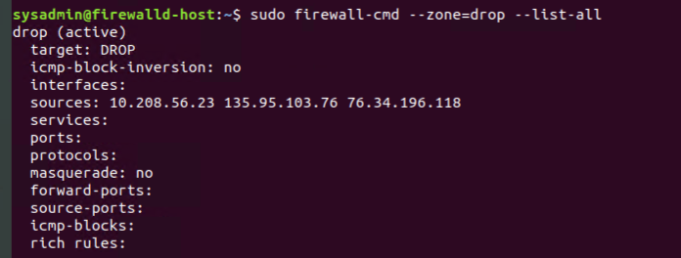

- Are all of our rules in place? If not, then go back and make the necessary modifications before checking again.

Congratulations! You have successfully configured and deployed a fully comprehensive `firewalld` installation.

---

**### Part 3: IDS, IPS, DiD and Firewalls**

Now, we will work on another lab. Before you start, complete the following review questions.

**#### IDS vs. IPS Systems**

1. Name and define two ways an IDS connects to a network.

**Answer 1: *Network Intrusion Detection systems (NIDS)*** *- an independent platform that identifies intrusions by examining network traffic and monitors multiple hosts. Network intrusion detection systems gain access to network traffic by connecting to a network hub, a network switch configured for port mirroring or a network tap. In a NIDS, sensors are placed at choke points in the network to monitor, often in the demilitarized zone (DMZ) or at network borders. Sensors capture all network traffic and analyze the content of individual packets for malicious traffic. An example of a NIDS is Snort.*

**Answer 2: *Host-based intrusion detection (HIDS) -*** *runs locally on a host-based system or user’s workstation server. Examines entire file systems on a host, compares them to previous snapshots or baselines, and generates an alert if there are significant differences between the two.*

2. Describe how an IPS connects to a network.

**Answer:** *The IPS is placed inline (in the direct communication path between source and destination), actively analyzing and taking automated actions on all traffic flows that enter the network. Specifically, these actions include:*

* *Sending an alarm to the administrator (as would be seen in an IDS)*
* *Dropping the malicious packets*
* *Blocking traffic from the source address*
* *Resetting the connection*

*As an inline security component, the IPS must work efficiently to avoid degrading network performance. It must also work fast because exploits can happen in near real-time. The IPS must also detect and respond accurately, so as to eliminate threats and false positives (legitimate packets misread as threats).*

3. What type of IDS compares patterns of traffic to predefined signatures and is unable to detect Zero-Day attacks?

**Answer:** *Signature-based intrusion detection*

4. Which type of IDS is beneficial for detecting all suspicious traffic that deviates from the well-known baseline and is excellent at detecting when an attacker probes or sweeps a network?

**Answer:** *Anomaly-based intrusion detection*

**#### Defense in Depth**

1. For each of the following scenarios, provide the layer of Defense in Depth that applies:

1. A criminal hacker tailgates an employee through an exterior door into a secured facility, explaining that they forgot their badge at home.

**Answer:** *Physical*

2. A zero-day goes undetected by antivirus software.

**Answer:** *Application*

3. A criminal successfully gains access to HR’s database.

**Answer:** *Data*

4. A criminal hacker exploits a vulnerability within an operating system.

**Answer:** *Host*

5. A hacktivist organization successfully performs a DDoS attack, taking down a government website.

**Answer:** *Network*

6. Data is classified at the wrong classification level.

**Answer:** *Policy, procedures & awareness*

7. A state sponsored hacker group successfully firewalked an organization to produce a list of active services on an email server.

**Answer:** *Perimeter*

2. Name one method of protecting data-at-rest from being readable on hard drive.

**Answer:** *Encryption*

3. Name one method to protect data-in-transit.

**Answer:** *Encrypt sensitive data prior to moving and/or use encrypted connections (HTTPS, SSL, TLS, FTPS, etc) to protect the contents of data in transit*

4. What technology could provide law enforcement with the ability to track and recover a stolen laptop.

**Answer:** *using GPS or Wi-Fi geolocation*

5. How could you prevent an attacker from booting a stolen laptop using an external hard drive?

**Answer:** *Full disk encryption encrypts the entire disk including swap files, system files and hibernations files. If an encrypted disk is stolen, lost, or placed into another computer, the encrypted state of the drive remains unchanged, and only an authorized user can access its contents.*

**#### Firewall Architectures and Methodologies**

1. Which type of firewall verifies the three-way TCP handshake? TCP handshake checks are designed to ensure that session packets are from legitimate sources.

**Answer:** *Circuit-level firewalls*

2. Which type of firewall considers the connection as a whole? Meaning, instead of looking at only individual packets, these firewalls look at whole streams of packets at one time.

**Answer:** *Packet-Filtering Firewalls (Stateful)*

3. Which type of firewall intercepts all traffic prior to being forwarded to its final destination. In a sense, these firewalls act on behalf of the recipient by ensuring the traffic is safe prior to forwarding it?

**Answer:** *Application (Proxy) Firewalls*

4. Which type of firewall examines data within a packet as it progresses through a network interface by examining source and destination IP address, port number, and packet type- all without opening the packet to inspect its contents?

**Answer:** *Stateless Packet-Filtering Firewalls*

5. Which type of firewall filters based solely on source and destination MAC address?

**Answer:** *MAC Layer Firewall*

**### Bonus Lab: "Green Eggs & SPAM"**

In this activity, you will target spam, uncover its whereabouts, and attempt to discover the intent of the attacker.

- You will assume the role of a Jr. Security administrator working for the Department of Technology for the State of California.

- As a junior administrator, your primary role is to perform the initial triage of alert data: the initial investigation and analysis followed by an escalation of high priority alerts to senior incident handlers for further review.

- You will work as part of a Computer and Incident Response Team (CIRT), responsible for compiling **Threat Intelligence** as part of your incident report.

**#### Threat Intelligence Card**

**Note**: Log into the Security Onion VM and use the following **Indicator of Attack** to complete this portion of the homework.

Locate the following Indicator of Attack in Sguil based off of the following:

- **Source IP/Port**: `188.124.9.56:80`

- **Destination Address/Port**: `192.168.3.35:1035`

- **Event Message**: `ET TROJAN JS/Nemucod.M.gen downloading EXE payload`

Answer the following:

1. What was the indicator of an attack?

- Hint: What do the details of the reveal?

**Answer:**

2. What was the adversarial motivation (purpose of attack)?

**Answer:**

3. Describe observations and indicators that may be related to the perpetrators of the intrusion. Categorize your insights according to the appropriate stage of the cyber kill chain, as structured in the following table.

| TTP | Example | Findings |

| --- | --- | --- |

| **Reconnaissance** | How did they attacker locate the victim? |

| **Weaponization** | What was it that was downloaded?|

| **Delivery** | How was it downloaded?|

| **Exploitation** | What does the exploit do?|

| **Installation** | How is the exploit installed?|

| **Command & Control (C2)** | How does the attacker gain control of the remote machine?|

| **Actions on Objectives** | What does the software that the attacker sent do to complete it's tasks?|

**Answer:**

4. What are your recommended mitigation strategies?

**Answer:**

5. List your third-party references.

**Answer:**

---

© 2020 Trilogy Education Services, a 2U, Inc. brand. All Rights Reserved.